Custom YD-GD370 Series Parameter Comparison Table | Strip-Cut Shredding Performance
定制YD-GD370系列参数对比表 | 切条切断效果
Image 1: Side view of the whole machine  图1：整机侧面图 |  | Image 2: Discharge outlet  图2：出料口 |  | Image 3: Overall view of the machine with additional discharge conveyor belt  图3： 整机大图 加配出料输送带  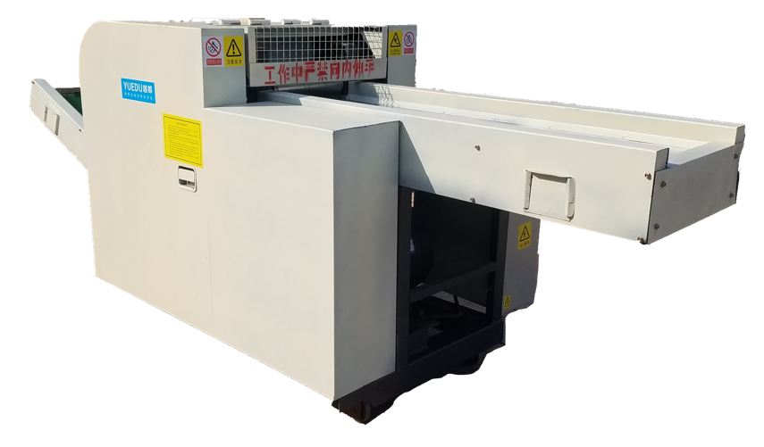  Image 4: Overall view of the machine with additional discharge conveyor belt at the customer site  图4：整机 加配出料输送带 用户现场  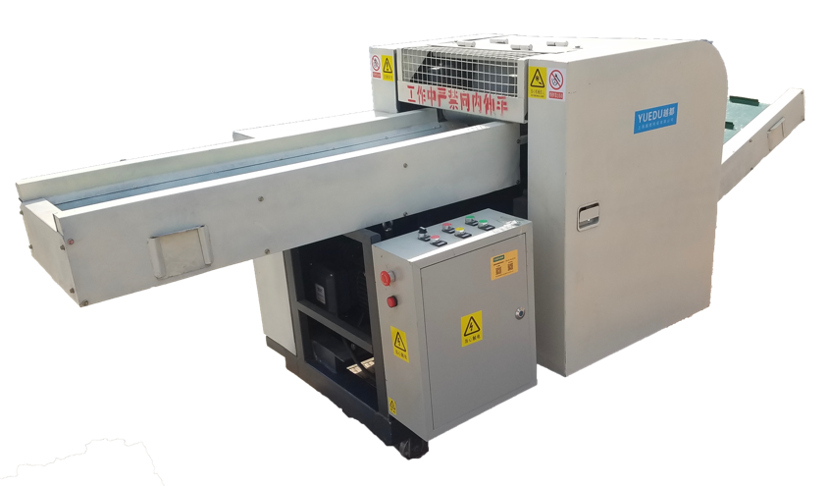
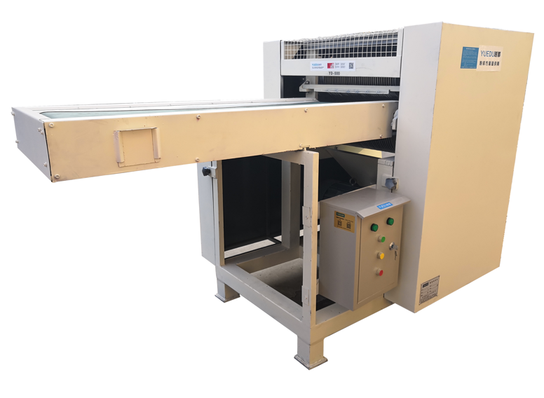 |  | 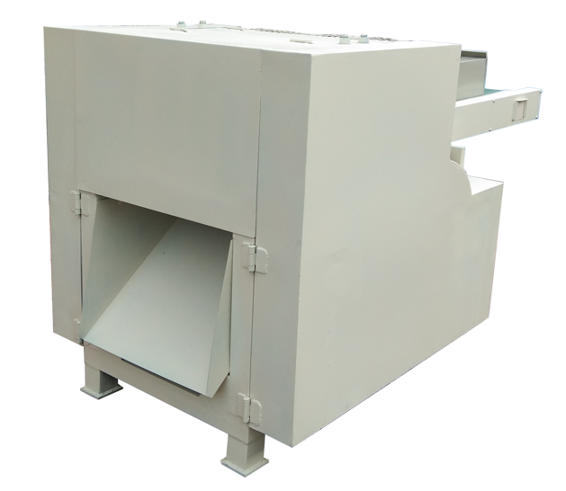
Effects of various materials (strip and block):
各类材料效果（条状 和 块状）
Strip: Adhesive  条状：不干胶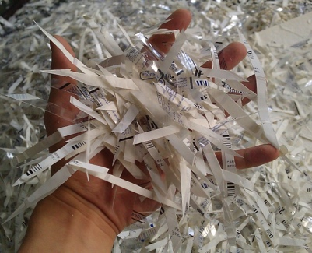 | Strip: Wood fiber board  条状：木质纤维板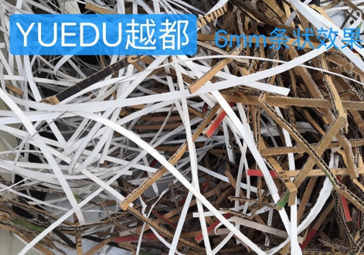 |  | Strip: Paper  条状：纸张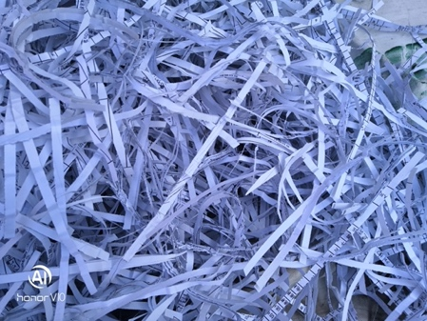
The blades are wear-resistant and have a long service life, making them suitable for shredding various sensitive materials. The main body of the shredder is welded with Q345B material and undergoes stress relief treatment, ensuring good stability, impact resistance, and vibration resistance, thus ensuring safe operation under long-term heavy loads. Shredding Effect: Customized output in strip or chip form according to customer requirements (as shown in the figure above). Discharge Method: Can be connected to an external discharge conveyor or central suction duct. Can shred: Wood cellulose, paper, film, cardboard, etc.
刀具耐磨、使用寿命长，适合多种涉密介质的粉碎；该碎纸机主机体采用Q345B材料焊接、消除应力处理，具有良好的稳定性、抗冲击性、振动性，确保设备在长时间重负荷中安全运行。粉碎效果：根据客户要求，定制出料条状或者出料片状（如上图）。出料方式：可外接出料输送线或中央吸风管道。可碎：木质纤维素,纸张,菲林,纸箱,等。
技术参数：
Product Model  产品型号 | YD-GD370A型 | YD-GD370B型 变频控制
Entry Width  入口宽度 | 370mm（可定制宽度，如42cm,60cm,80cm）
Shredded Size [1]  粉碎后尺寸 | Size A1: Options for strip sizes of 2.5cm, 5cm, and 8cm.  尺寸A1：2.5CM， 5CM，8CM 条状可选  Size A2: Options for strip sizes of 1cm, 3cm, and 5cm.  尺寸A2：1CM，3CM，5CM条状可选 | Size B1: 8mm strips (operators can adjust shredding size from 8 to 80mm strips).  尺寸B1：8mm条（操作人员可自行调整粉碎尺寸8 ~ 80mm条）  Size B2: 3mm strips (operators can adjust shredding size from 3 to 30mm strips).  尺寸B2：3mm条（操作人员可自行调整粉碎尺寸3 ~ 30mm条）
Total Motor Power  电机总功率 | 7KW | 7KW
Input Belt  输 入 带 | 1400*330mm；Standard factory configuration, extendable according to user requirements for convenient on-site feeding by specific users. 出厂标配，可根据用户需求延长，方便特定用户现场进料
Output Belt  输 出 带 | 1400*330mm；Optional: Standard factory configuration does not include discharge conveyor belt. 选配，出厂标准配置不含出料输送带
Main Machine Dimensions  主 机 尺 寸 | 2100*1000*1100mm
Capacity  产 量 | 300-500kg/h
Product Price  产品价格 | Size A1: RMB 34,100  尺寸A1：34100元  Size A2: RMB 36,100  尺寸A2：36100元 | Size B1: RMB 36,786  尺寸B1：36786元  Size B2: RMB 38,786  尺寸B2：38786元
Description: This model belongs to the belt-fed shredder series, commonly used in waste disposal stations and large-scale document destruction centers.
说明：本机型为皮带进料碎纸系列，常用于废品站和大型文件销毁中心。

Typical customization requirements for this model include:
1. Shredding capacity of over 500 sheets per cycle;
2. Shredded particle size of 2*15mm or 4*40mm;
3. Hourly output of 1.5 tons, with daily shredding volume exceeding 10 tons;
4. Blade shredding width, inlet sizes of 42cm, 60cm, 80cm, 120cm, etc.
Recommendations will be provided based on specific usage requirements. Feel free to contact customer service for further assistance!本机型典型定制需求如：
1. 每次可以粉碎500张以上；
2. 粉碎尺寸2*15mm 或 4*40mm；
3. 每小时产量1.5吨，每天粉碎量在10吨以上；
4. 刀具碎纸宽度，入口尺寸42cm,60cm,80cm,120cm等；
需要根据具体使用需求推荐，欢迎直接咨询客服！

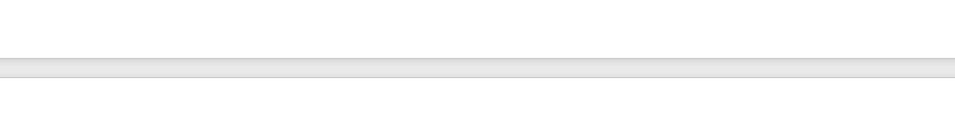

YD-GD370B
Belt Conveyor Shredder
越都 YD-GD370B碎纸机

皮带输送带碎纸机 销毁中心

The blades are wear-resistant and have a long service life, making them suitable for shredding various sensitive materials. This shredder has good stability, impact resistance, and vibration resistance, ensuring safe operation under long-term heavy loads. Shredding Effect: Customized output in strip or chip form according to customer requirements. Discharge Method: Can be connected to an external discharge conveyor or central suction duct. Can shred: Wood cellulose, paper, film, cardboard, etc.
刀具耐磨、使用寿命长，适合多种涉密介质的粉碎；该碎纸机具有良好的稳定性、抗冲击性、振动性，确保设备在长时间重负荷中安全运行。粉碎效果：根据客户要求，定制出料条状或者出料片状（如上图）。出料方式：可外接出料输送线或中央吸风管道。可碎：木质纤维素,纸张,菲林,纸箱,等。

Effects of Different Materials
(Strip and Chunk)
各类材料效果（条状 和 块状）

Strip: Adhesive  条状：不干胶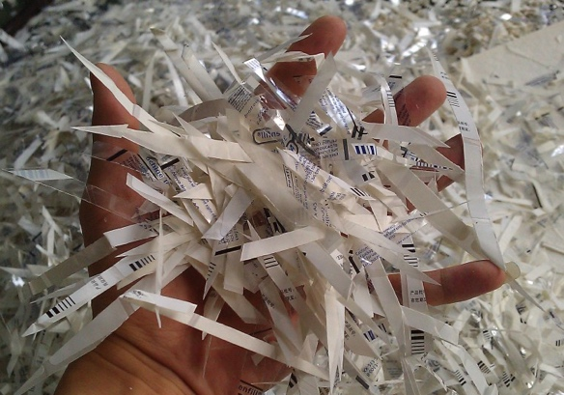 | Strip: Wood fiber board  条状：木质纤维板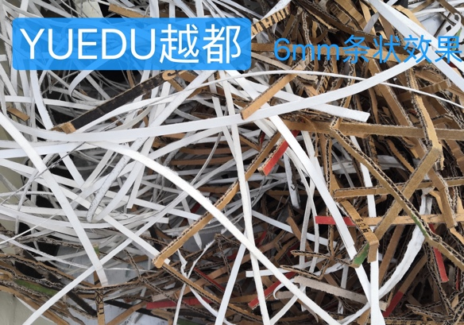 | Strip: Paper  条状：纸张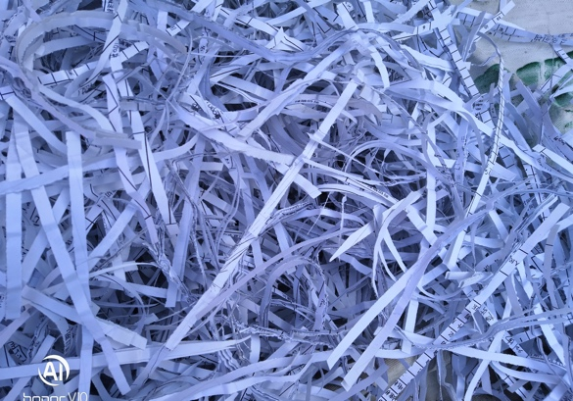
Block: Fabric fiber  片状：布料纤维  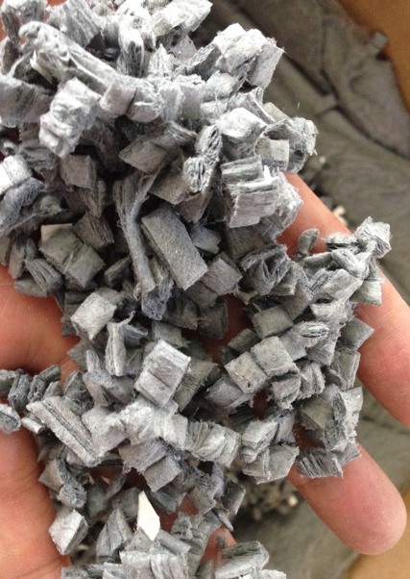 | Block: Wood fiber  片状：木质纤维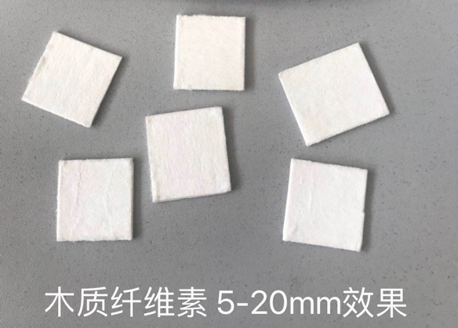 | Block: Wood fiber 2  片状：木质纤维2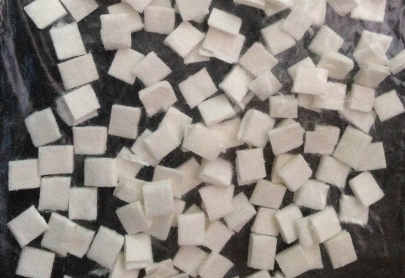
Note: The machine defaults to strip shredding. If block shredding is required, please contact customer service to specify customized requirements (additional charges apply).
注明：机器默认为粉碎条状，如需块状效果，请联系客服说明定制需求（额外收费）

Equipment Details Diagram
设备详情图

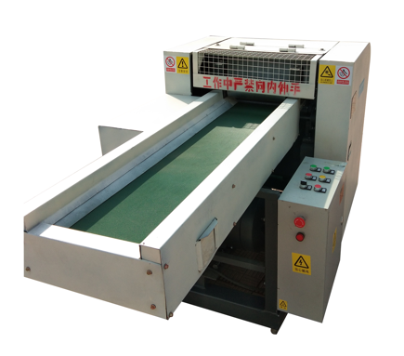 | 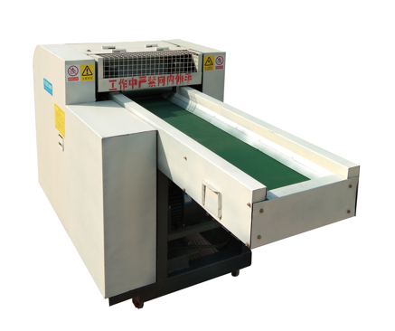 | 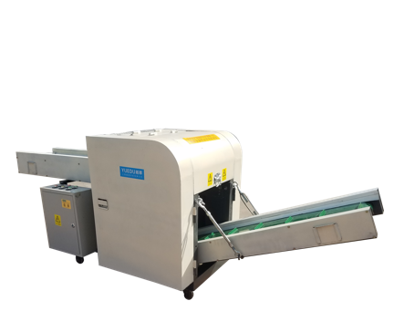
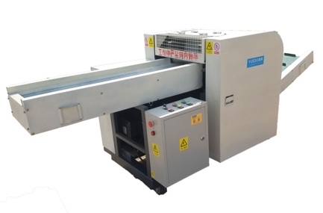 | 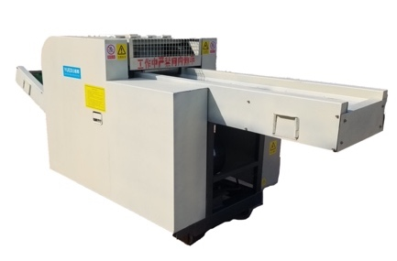 | 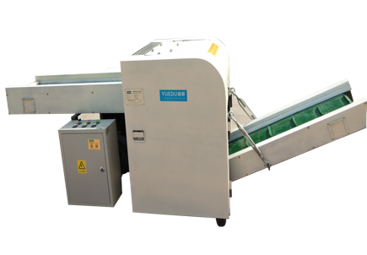

Product in Use
(Customer Testimonial)
产品使用现场（客户见证）

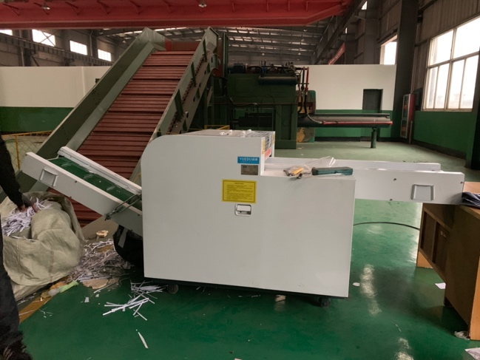 | 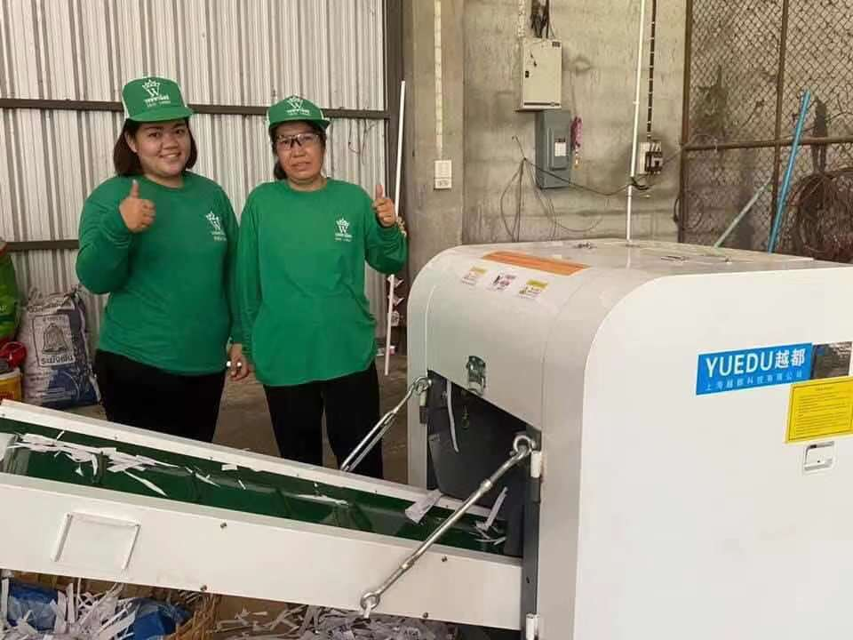
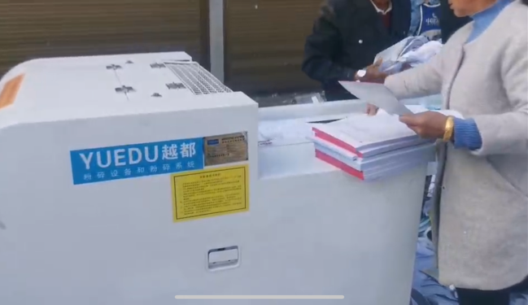 | 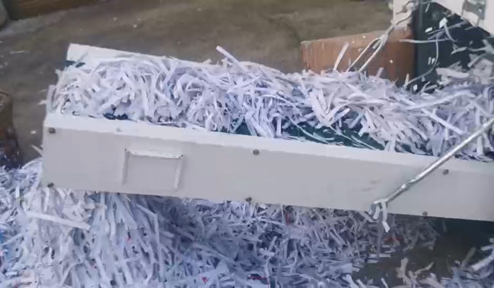

Installation Dimension Diagram (Three Views)
安装尺寸图（三视图）

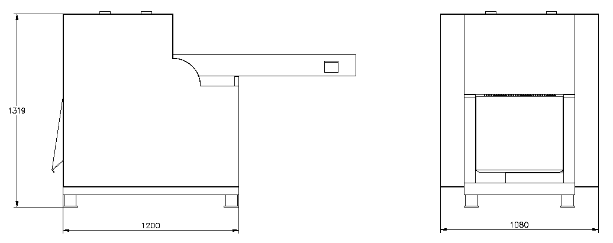
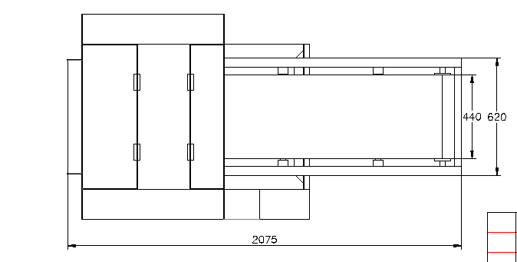
Note: The dimensions may vary after equipment updates. If precise dimension accuracy is required, please confirm the exact installation dimensions with customer service before placing an order.
注：设备更新换代后尺寸会有变化，如果对于尺寸精确度要求高，请下单前与客服确认精确的安装尺寸。

Case 1: Delivery Diagram of a Printing and Packaging Factory

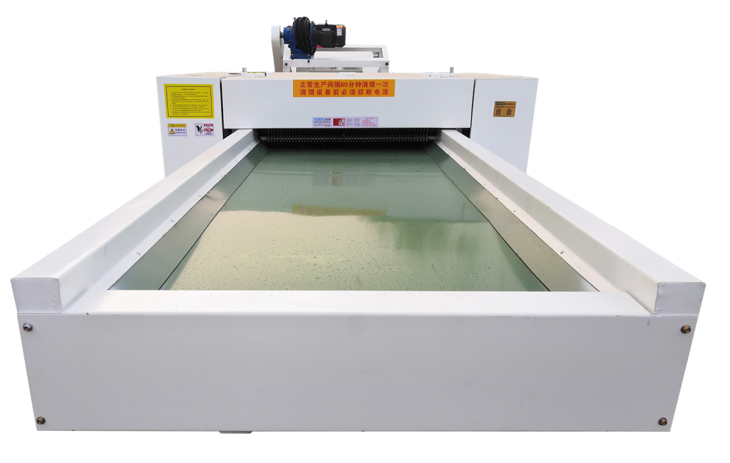 | 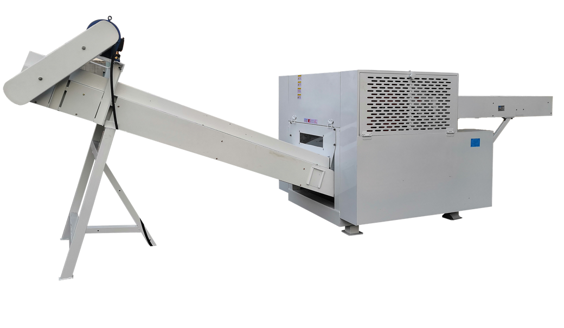
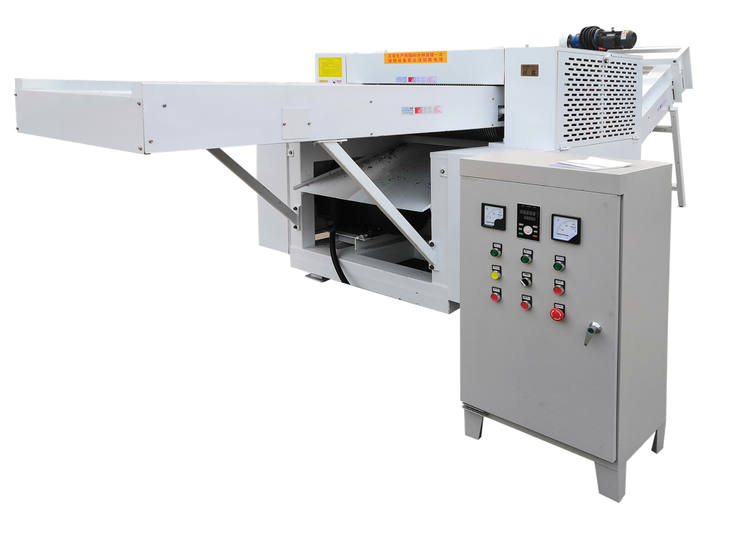 | 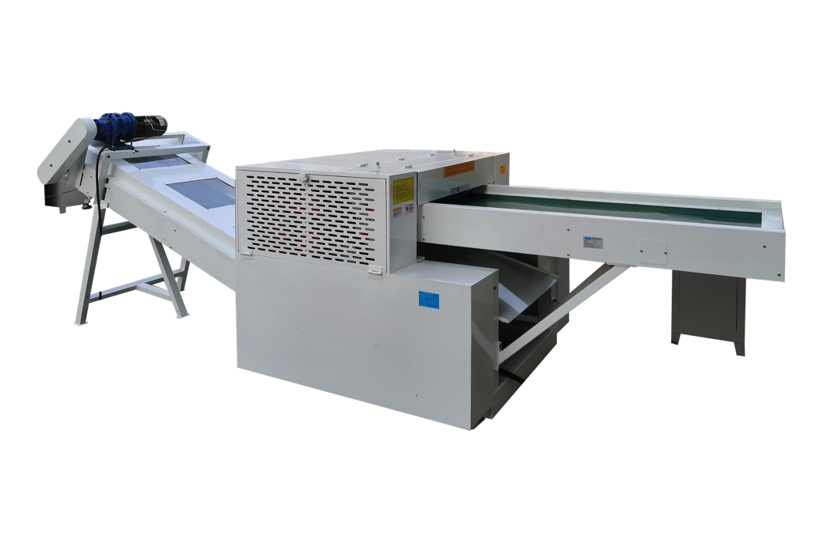
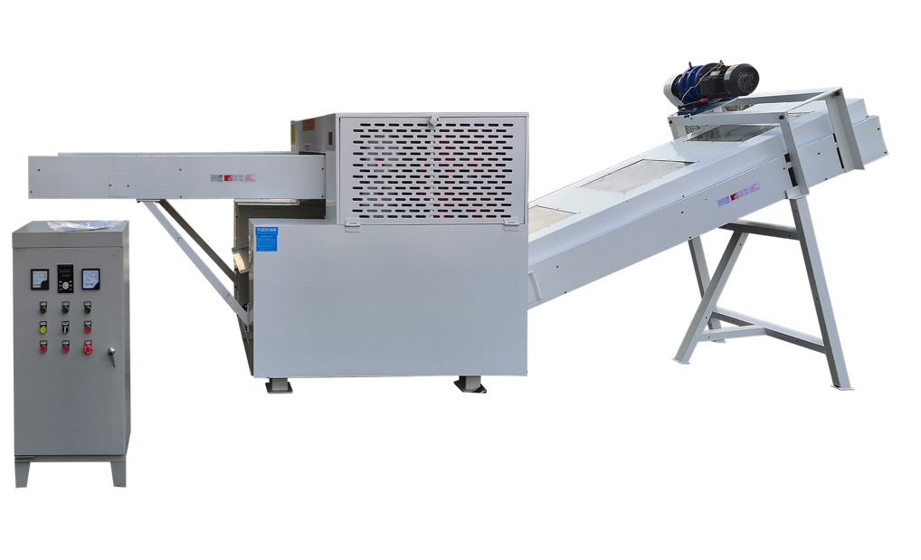 | 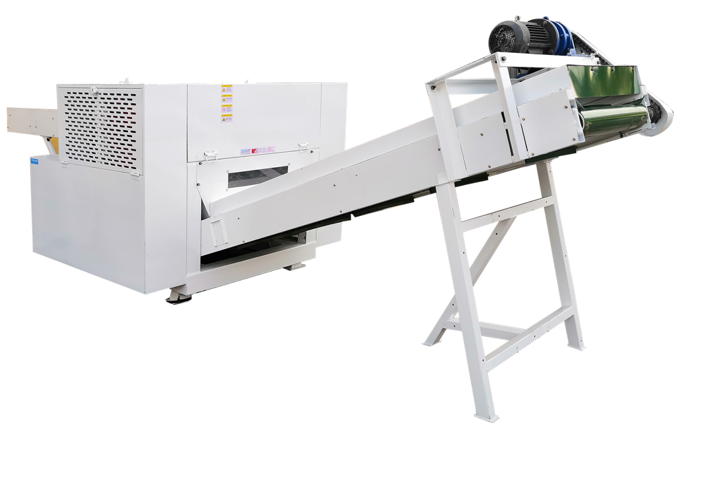

Case 1: Installation Dimension Diagram (Three Views)

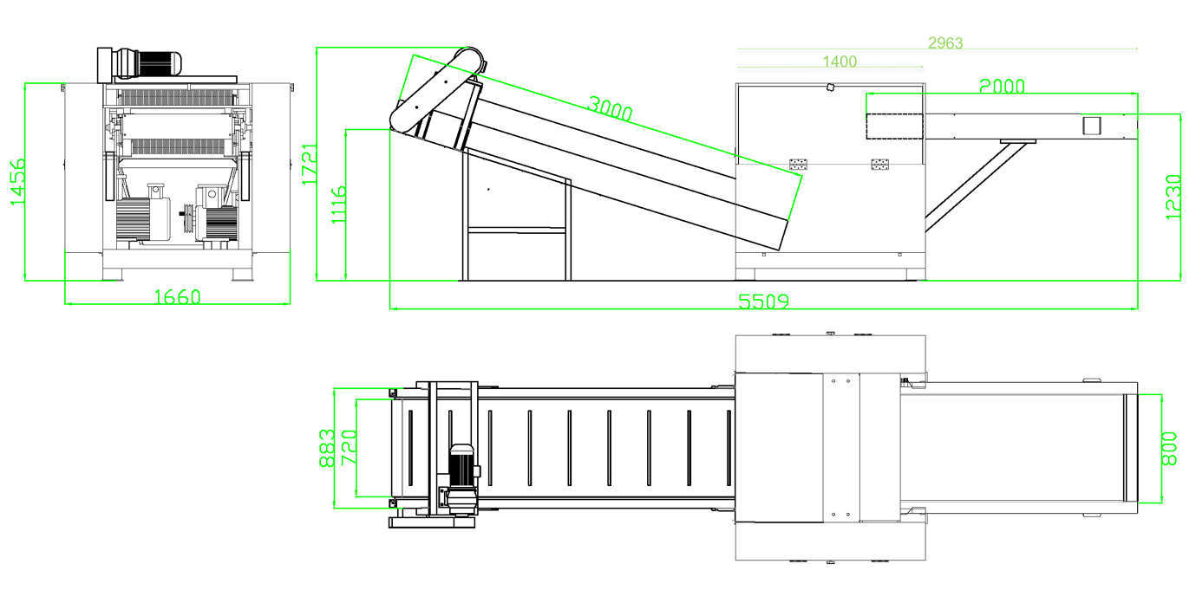
🍭The dimensions confirmed by both parties shall prevail when placing the order.

Case 2: 800mm Inlet Effect and Three Views

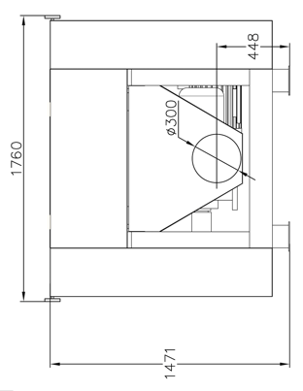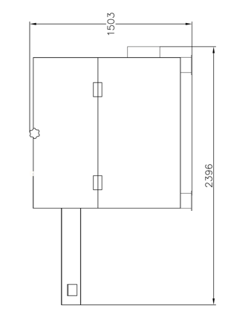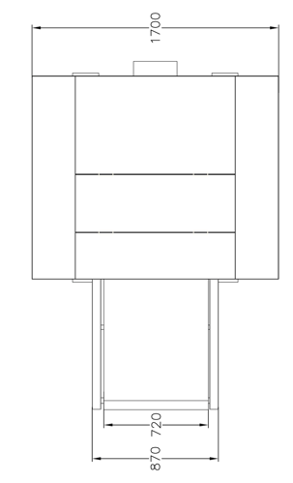

可根据客户要求定制粉末状粉碎效果。

